LAB – 1 REPORT
Name: Ozan Berk Gultegin
Submission Date:

Purpose of the Work
The main objective of this work:
- To develop a program for visualizing audio signals in the time domain
- To analyze digital audio quality parameters
  - Sampling Rate
  - Bit depth
  - Number of channels
- To implement segmentation for extraction and saving
- Comparing different audio recordings using time-domain characteristics

Work Results
  - II.I Graphical Result
  - 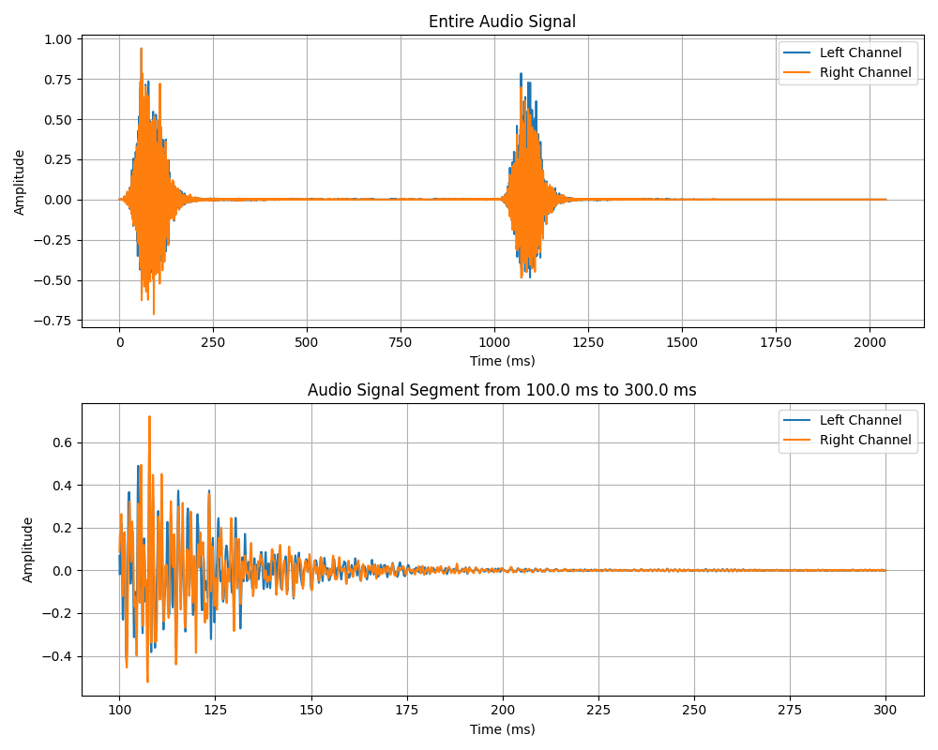
  - Figure 1: Time-domain representation of audio signal.
Information about the scanned signal:
- Sampling rate: 44100 Hz
- Number of channels: 2
- Quantization bits: PCM_16 (16-bit depth)

Summary and Conclusion
Developed program successful:
- Visualizes both mono and stereo recordings
- Extracts precise temporal segments
- Preserves original quality parameters when saving segments

Conclusion
1. Digital audio quality can be quantitatively assessed through its technical parameters.
2. Time-domain visualization helps identify:
- Transient events (clicks, pauses, jumps)
- Amplitude variations
- Channel differences in stereo recordings.
3. The 44.1 kHz/16-bit standard remains sufficient for most speech applications.

